Operating System Lab Manual

# Lab – 2 Jaivik Jariwala 21BCP004

Perform the following Linux Fedodra command operations

1. ifconfig : Display network interfaces and IP addresses.

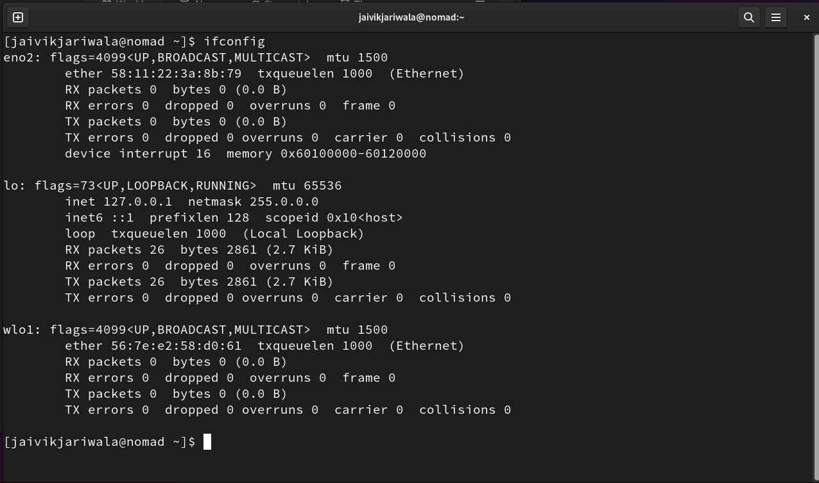

2. kill: Kill active processes by process ID or name

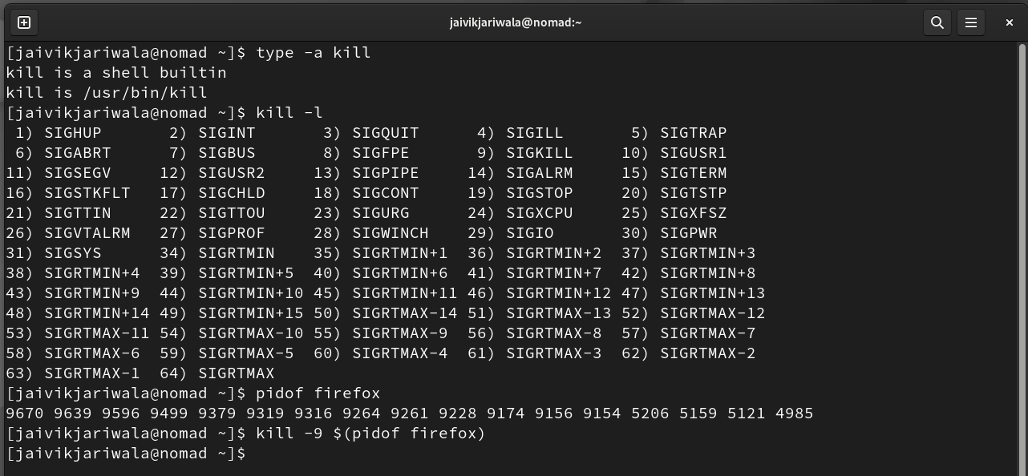

3. mount : Mount file systems in Linux

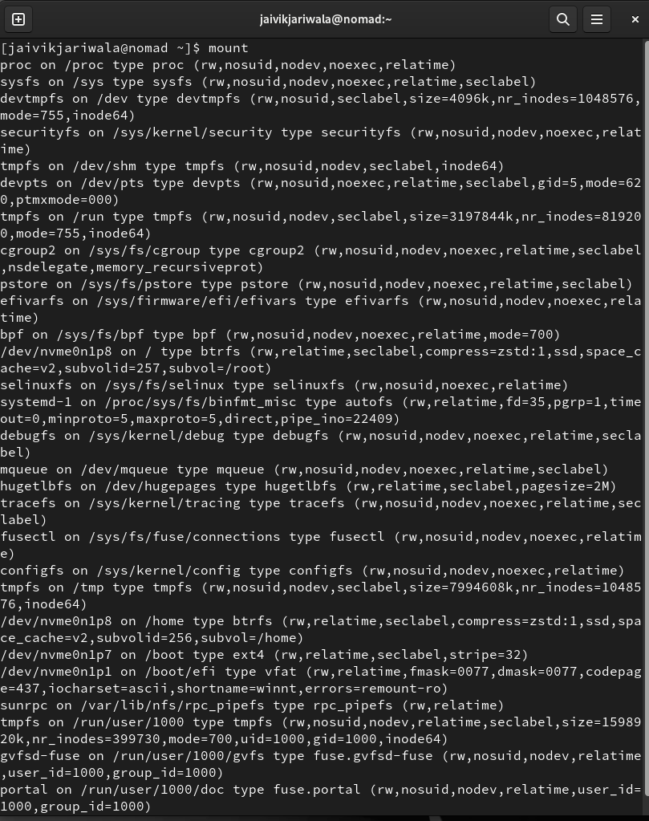

4. sort : Linux command to sort the content of a file while outputting

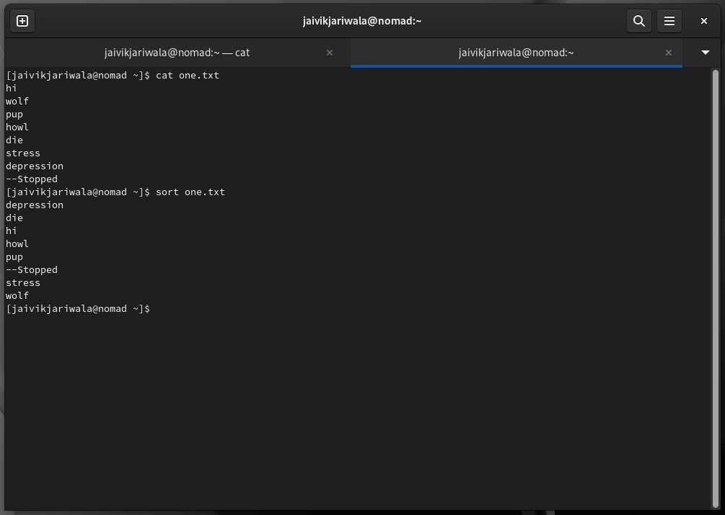

5. export : Export environment variables in Linux

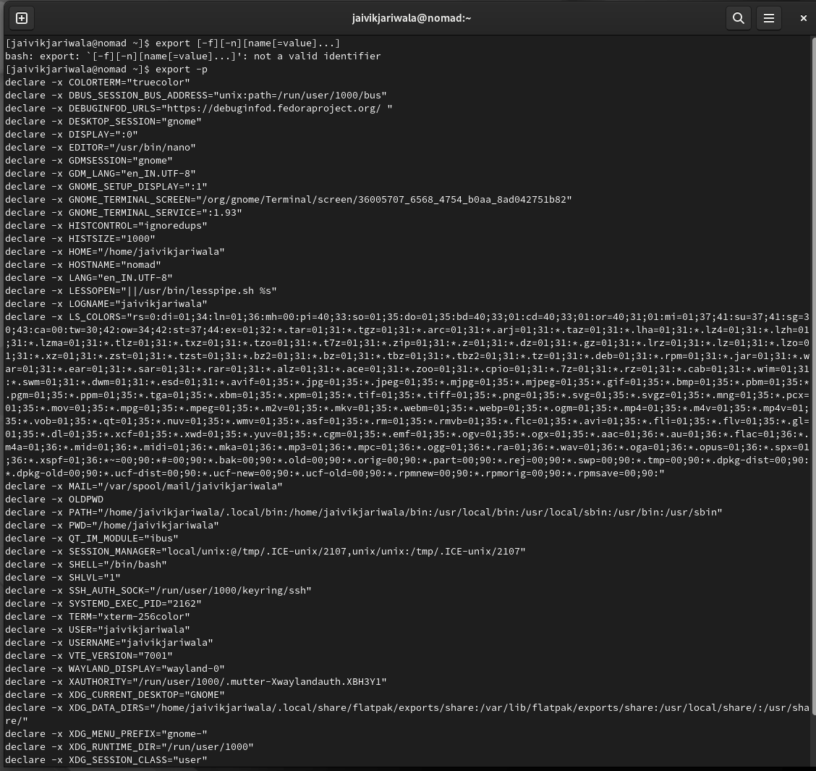

6. ssh : Secure Shell command in Linux

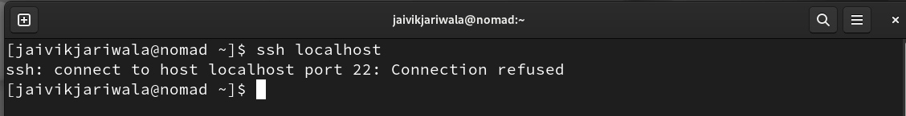

7. zip : Zip files in Linux

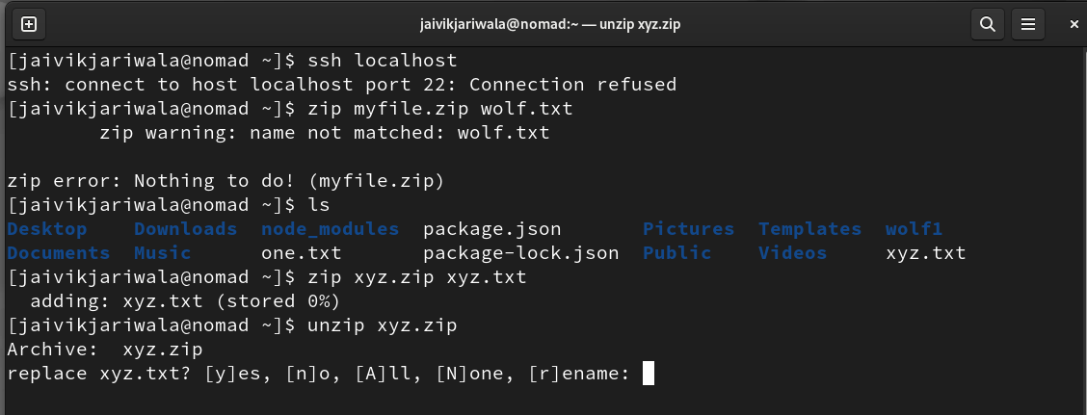

8. unzip : Unzip files in Linux

9. ps : Display active processes

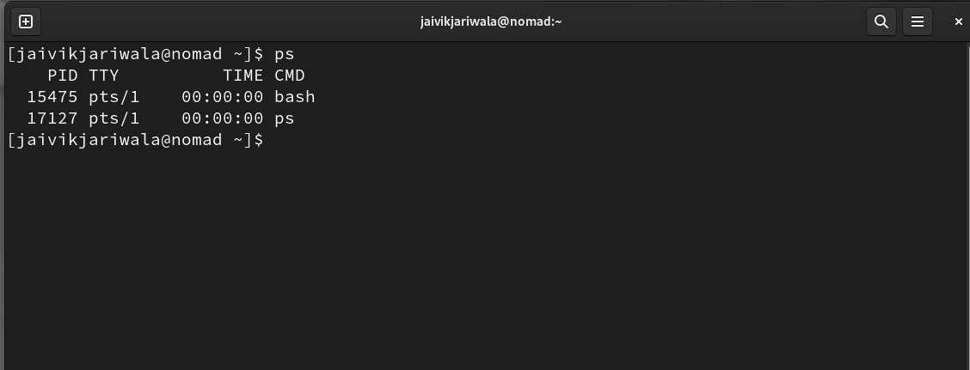

10. uname : Linux command to get basic information about the OS

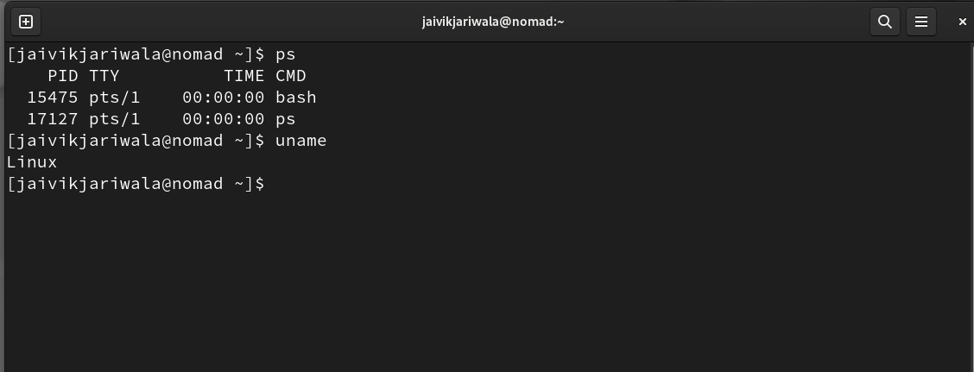

11. chown : Command for granting ownership of files or folders

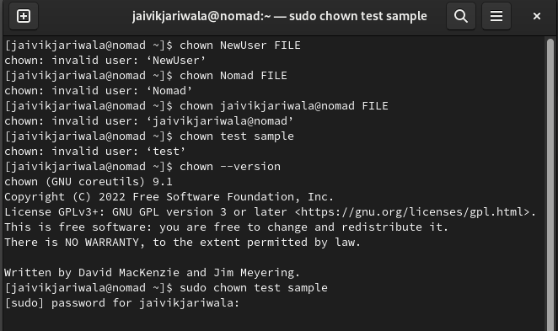

12. wget : Direct download files from the internet

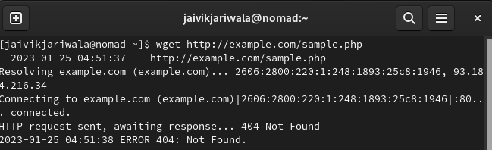

13. ufw : Firewall command

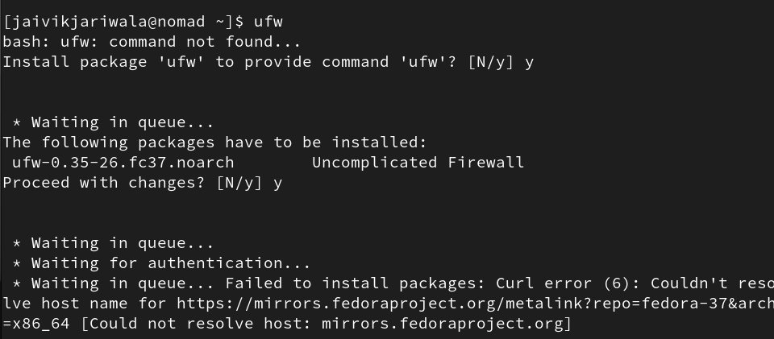

14. traceroute : Trace all the network hops to reach the destination

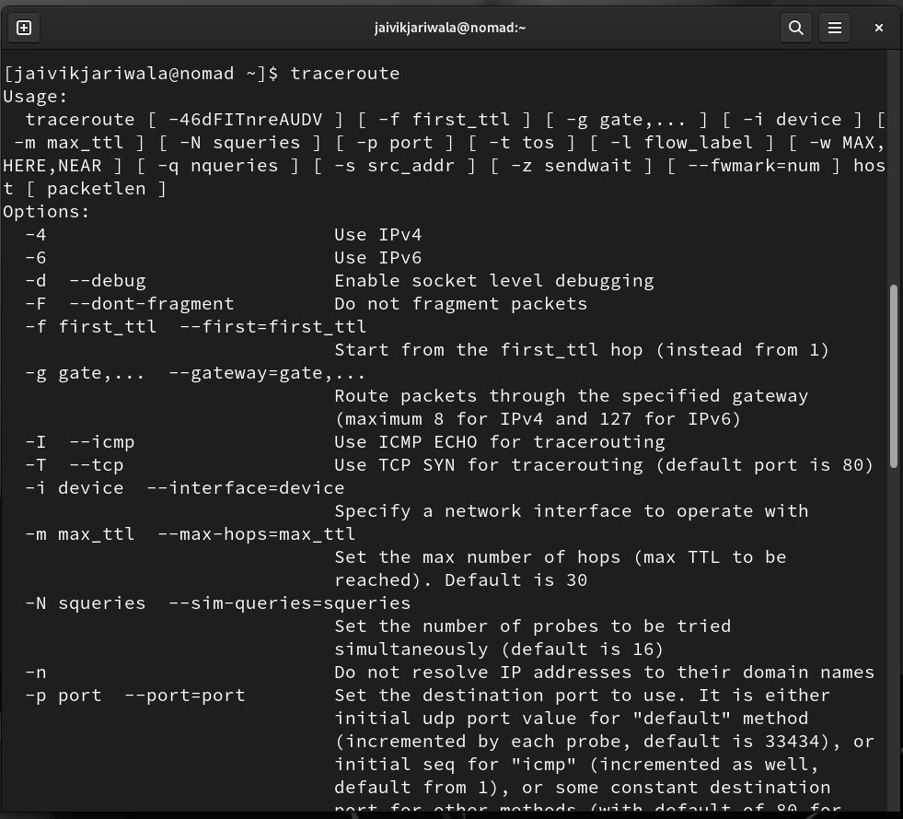

15. service : Linux command to start and stop services



16. alias : Create custom shortcuts for your regularly used commands

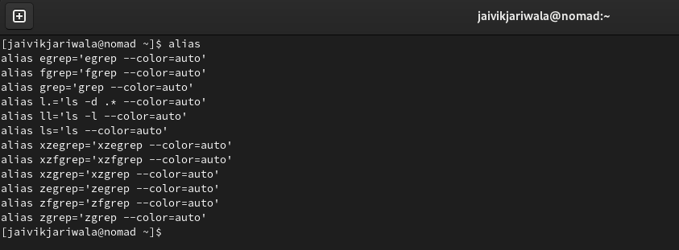

17. dd : Majorly used for creating bootable USB sticks

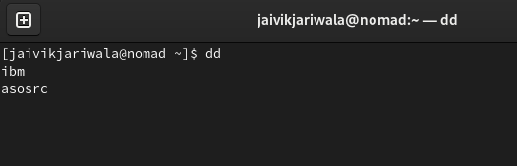

18. whereis : Locate the binary, source, and manual pages for a command

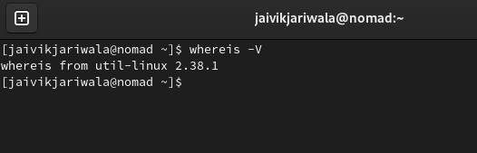

19. whatis : Find what a command is used for

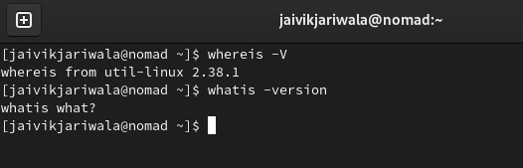

20. diff : Find the difference between two files

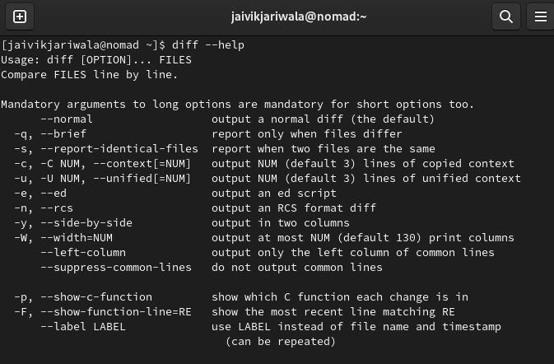

21. ln : Create symbolic links (shortcuts) to other files

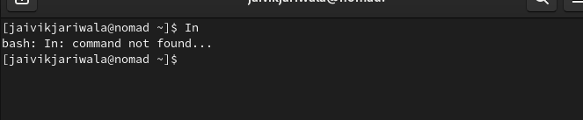

22. top : View active processes live with their system usage

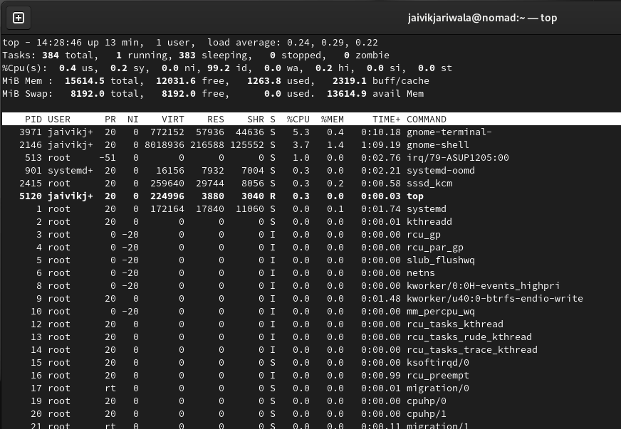

23. useradd : Add new user or change existing users data 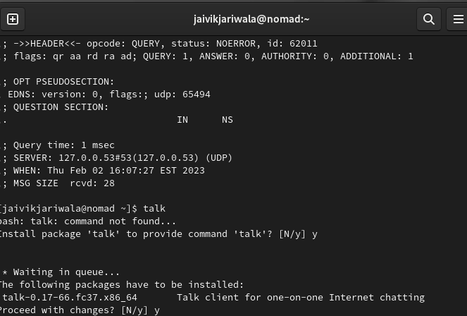

24. man : Access manual pages for all Linux commands

25. cp : Similar usage as mv but for copying files in Linux

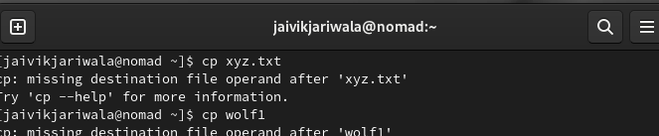

26. ln : Create symbolic links (shortcuts) to other files



27. netstat : netstat command displays various network related information such as network connections, routing tables, interface statistics, masquerade connections, multicast memberships etc.

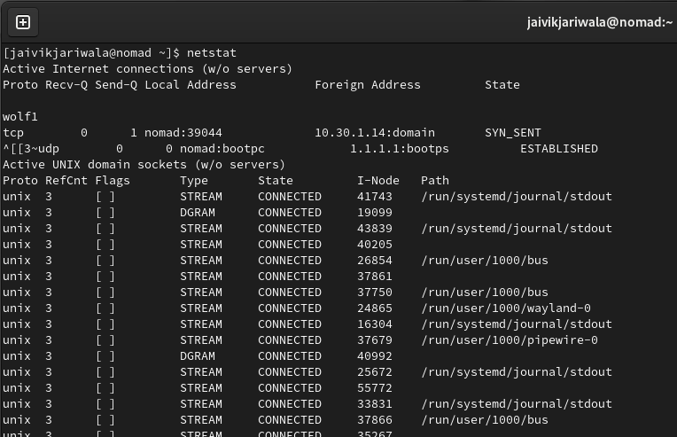

28. nslookup : A network utility program used to obtain information about Internet servers. As its name suggests, the utility finds name server information for domains by querying DNS.

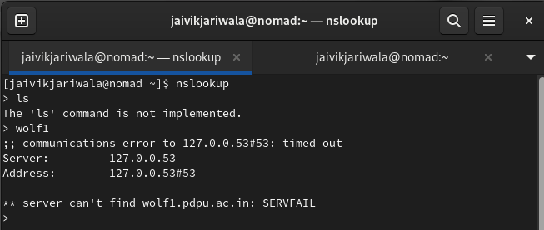

29. dig : dig is a tool for querying DNS nameservers for information about host addresses, mail exchanges, nameservers, and related information. This tool can be used from any Linux (Unix) or Macintosh OS X operating system. The most typical use of dig is to simply query a single host.

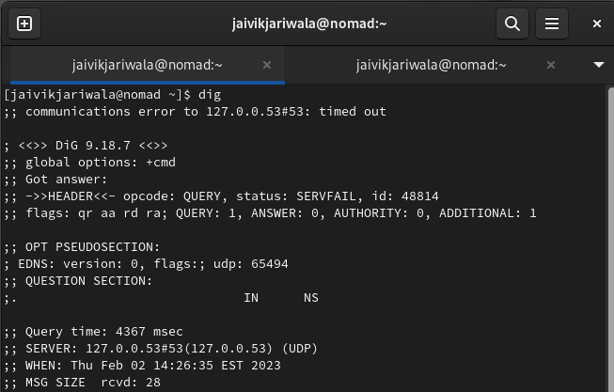

30. uptime : You have just connected to your Linux Server Machine and founds Something unusual or malicious, what you will do? Guessing…. NO, definitely not you could run uptime to verify what happened actually when the server was unattended.

31. wall : one of the most important command for administrator, wall sends a message to everybody logged in with their mesg permission set to “yes“. The message can be given as an argument to wall, or it can be sent to wall’s standard input. 

32. mesg : Lets you control if people can use the “write” command, to send text to you over the screen.

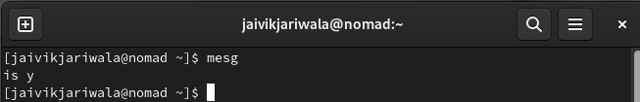

33. write : Let you send text directly to the screen of another Linux machine if ‘mesg’ is ‘y’.



34. talk : An enhancement to write command, talk command lets you talk to the logged in users.

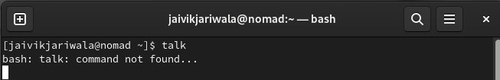

35. w : what command ‘w’ seems you funny? But actually it is not. t’s a command, even if it’s just one letter long! The command “w” is a combination of uptime and who commands given one immediately after the other, in that order.

36. rename : As the name suggests, this command rename files. rename will rename the specified files by replacing the first occurrence from the file name.

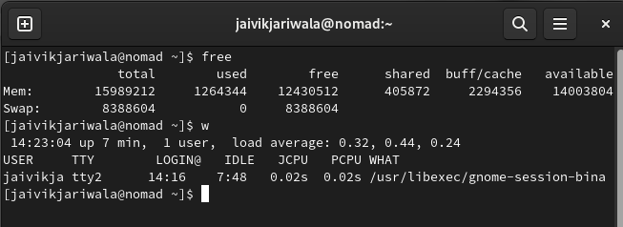

37. free : Keeping track of memory and resources is as much important, as any other task performed by an administrator, and ‘free‘ command comes to rescue here.

